SPA1 Burnley Central
Existing Service Delivery Premises | Calculated Service Delivery Premises | Proposed Reduction
9 | 5 | 4

SPA No. | SPA Name | Name | Current LCC functions
1 | Burnley Central | Burnley Youth Zone | Youth Zone | Youth Offending Team | Leaving Care Outreach
1 | Burnley Central | Burnley The Fold | Supporting Carers of Children and Young People
1 | Burnley Central | Coal Clough Library | Library
1 | Burnley Central | Burnley CAPSS (Easden Clough) | CAPSS Centre
1 | Burnley Central | Burnley City Learning Centre | Conferencing
1 | Burnley Central | Stoops and Hargher Clough YPC | Young People's Centre
1 | Burnley Central | Brunshaw Young People's Centre | Young People's Centre
1 | Burnley Central | Belmont Community Centre | Community Association - no LCC service
1 | Burnley Central | Pike Hill Library | Library

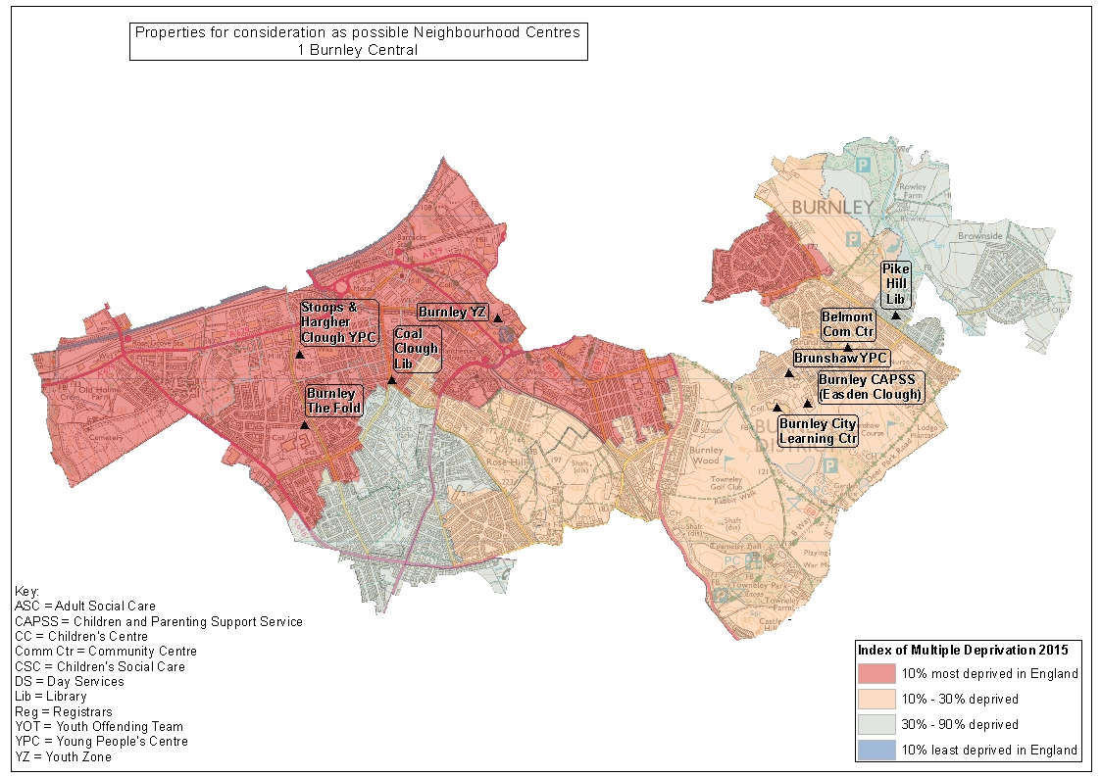
SPA2 Preston East
Existing Service Delivery Premises | Calculated Service Delivery Premises | Proposed Reduction
7 | 7 | 0

SPA No. | SPA Name | Name | Current LCC functions
2 | Preston East | Ribbleton Children's Centre | Children's Centre
2 | Preston East | Sunshine Children's Centre | Children's Centre
2 | Preston East | Preston East Children's Centre | Children's Centre
2 | Preston East | Ribbleton Library | Library
2 | Preston East | St Luke's Centre (Children's Social Care) | CAPSS Centre
2 | Preston East | Moor Nook Young People's Centre | Young People's Centre
2 | Preston East | Preston SureStart Fishwick and St Matthews (satellite) | Children's Centre

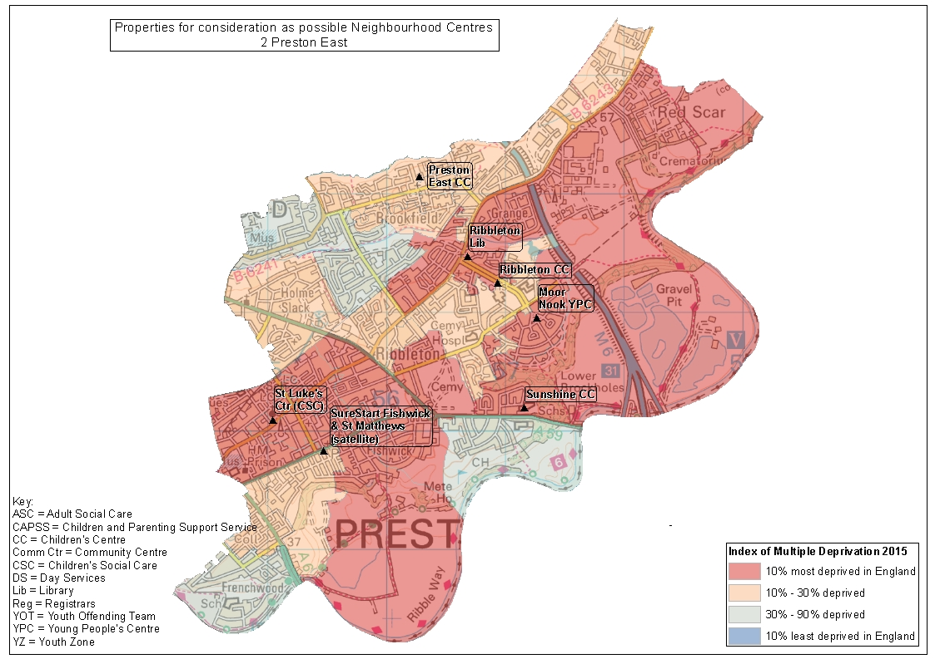
SPA3 Burnley North
Existing Service Delivery Premises | Calculated Service Delivery Premises | Proposed Reduction
7 | 5 | 2

SPA No. | SPA Name | Name | Current LCC functions
3 | Burnley North | Burnley And Pendle Service (Temple Street) | Disability Day Service
3 | Burnley North | Burnley Campus Library | Library | Children's Centre
3 | Burnley North | The Chai Centre | Children's Centre
3 | Burnley North | Burnley Library | Library
3 | Burnley North | Burnley Registrars | Registrars
3 | Burnley North | Stoneyholme and Daneshouse YPC | Young People's Centre
3 | Burnley North | Briercliffe Library | Library

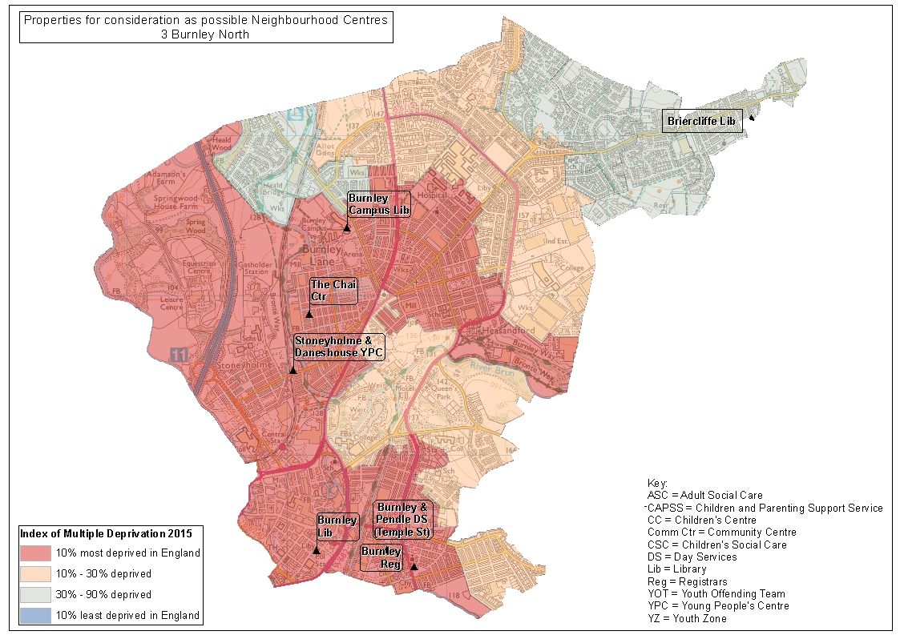
SPA4 Nelson and Brierfield
Existing Service Delivery Premises | Calculated Service Delivery Premises | Proposed Reduction
7 | 7 | 0

SPA No. | SPA Name | Name | Current LCC functions
4 | Nelson and Brierfield | Pendle Youth Zone | Youth Zone
4 | Nelson and Brierfield | Family Tree Children's Centre | Children's Centre
4 | Nelson and Brierfield | Brierfield Library | Library
4 | Nelson and Brierfield | Nelson Beacon Children's Centre | Children's Centre | Welfare Rights
4 | Nelson and Brierfield | Burnley and Pendle Day Service (Marsden Centre) | Disability Day Service
4 | Nelson and Brierfield | Nelson Library | Library
4 | Nelson and Brierfield | Brierfield Young People's Centre | Young People's Centre

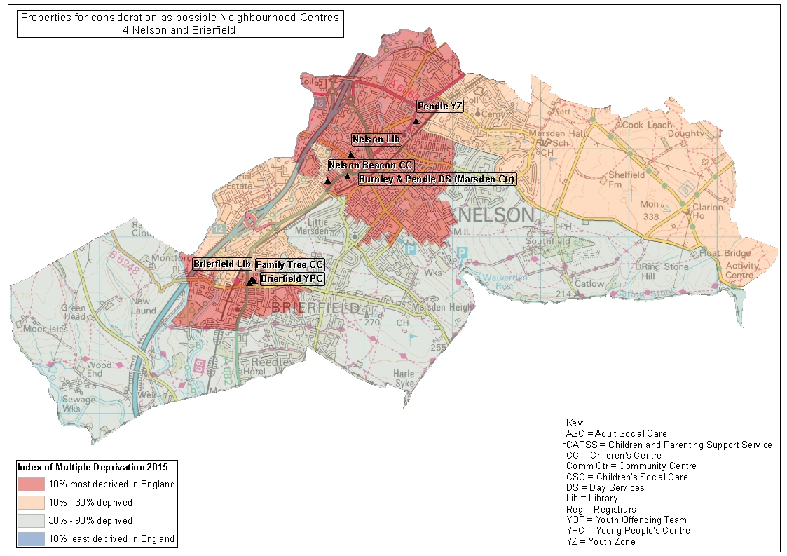
SPA5 Fleetwood
Existing Service Delivery Premises | Calculated Service Delivery Premises | Proposed Reduction
7 | 4 | 3

SPA No. | SPA Name | Name | Current LCC functions
5 | Fleetwood | Wyre CAPSS and West View Children's Centre | CAPSS Centre | Children's Centre
5 | Fleetwood | Fleetwood Library | Library | Registrars | Welfare Rights
5 | Fleetwood | Fleetwood Children's Centre (Kemp St) | Children's Centre
5 | Fleetwood | Northfleet Library | Library | Children's Centre
5 | Fleetwood | Wyre Youth Zone | Youth Zone
5 | Fleetwood | Fylde And Wyre Day Services (Larkholme) | Disability Day Service
5 | Fleetwood | Fleetwood Young People's Centre (Blakiston St) | Short Stay School Temporary use

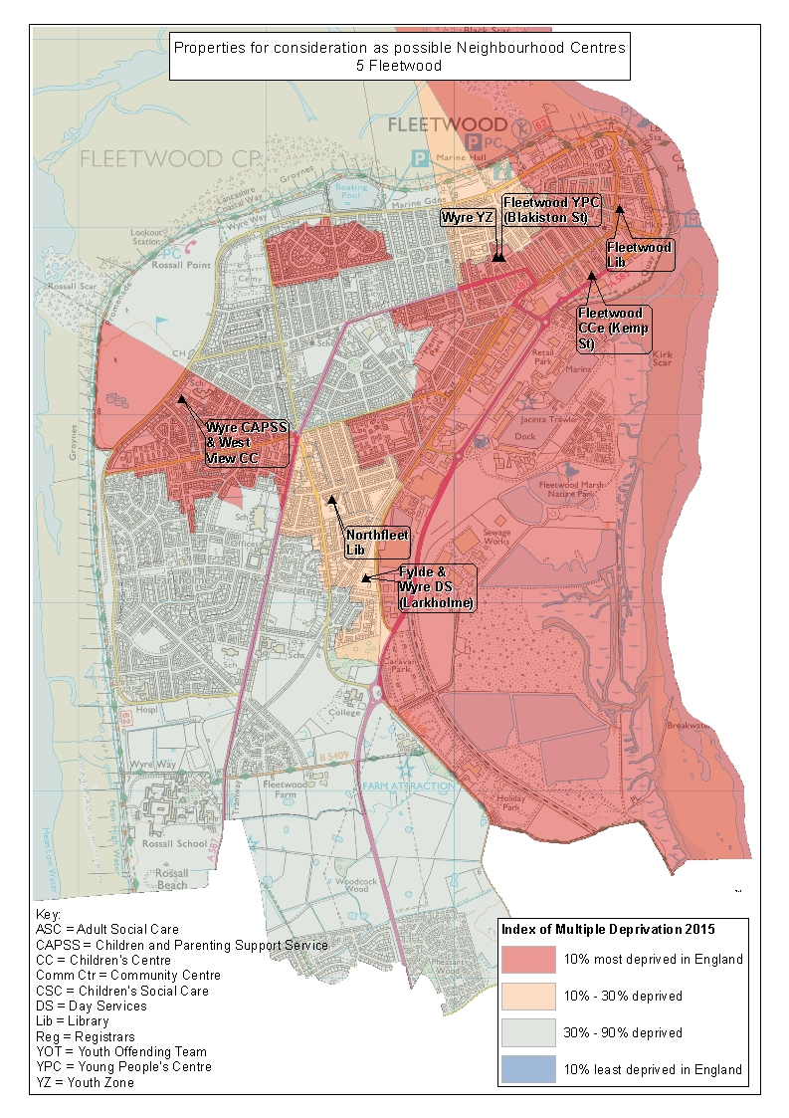
SPA6 Hyndburn East
Existing Service Delivery Premises | Calculated Service Delivery Premises | Proposed Reduction
12 | 8 | 4

SPA No. | SPA Name | Name | Current LCC functions
6 | Hyndburn East | Hyndburn Youth Zone | Youth Zone
6 | Hyndburn East | Accrington Library and Registrars | Library | Registrars
6 | Hyndburn East | Clayton-Le-Moors Young People's Centre | Young People's Centre
6 | Hyndburn East | Hyndburn Day Services (Enfield) | Disability Day Service
6 | Hyndburn East | Oswaldtwistle Library | Library
6 | Hyndburn East | Clayton-Le-Moors Library | Library
6 | Hyndburn East | Woodhaven Day Centre | Older People's Day Centre
6 | Hyndburn East | Oswaldtwistle Young People's Centre | Young People's Centre
6 | Hyndburn East | Silver Birches CAPSS | CAPSS Centre
6 | Hyndburn East | Accrington Youth OffendingTeam | Youth Offending Team
6 | Hyndburn East | Mount Pleasant Children's Centre | Children's Centre
6 | Hyndburn East | Huncoat Children's Centre | Children's Centre

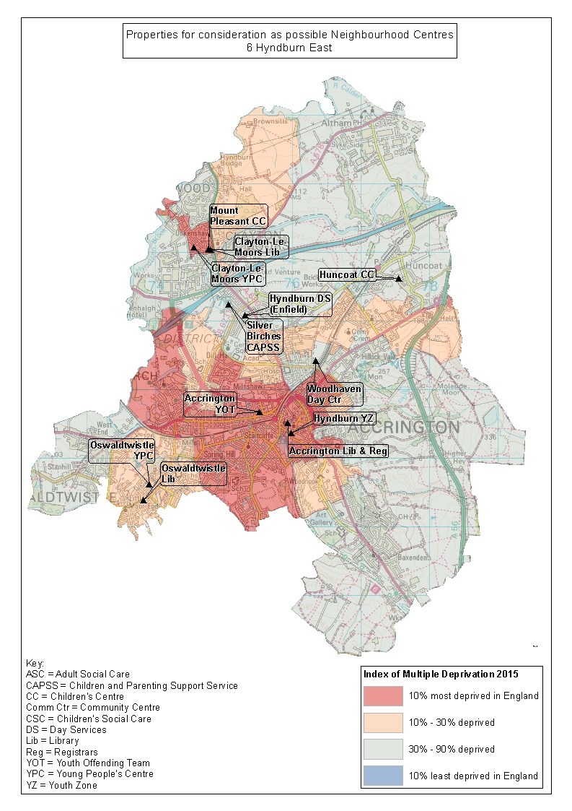
SPA7 Preston Central
Existing Service Delivery Premises | Calculated Service Delivery Premises | Proposed Reduction
6 | 5 | 1

SPA No. | SPA Name | Name | Current LCC functions
7 | Preston Central | Preston Registrars | Registrars |  | Records Office
7 | Preston Central | Preston Day Services (Ribblebank) | Disability Day Service
7 | Preston Central | Preston 58/60 Guildhall Street | Trading Standards Lab | Youth Offending Team |  | Welfare Rights | Young People's Service
7 | Preston Central | Riverbank Children's Centre | Children's Centre | Registrars |  | Supporting Carers of Children and Young People
7 | Preston Central | Ripon Street CAPSS | CAPSS
7 | Preston Central | Harris Library | Library

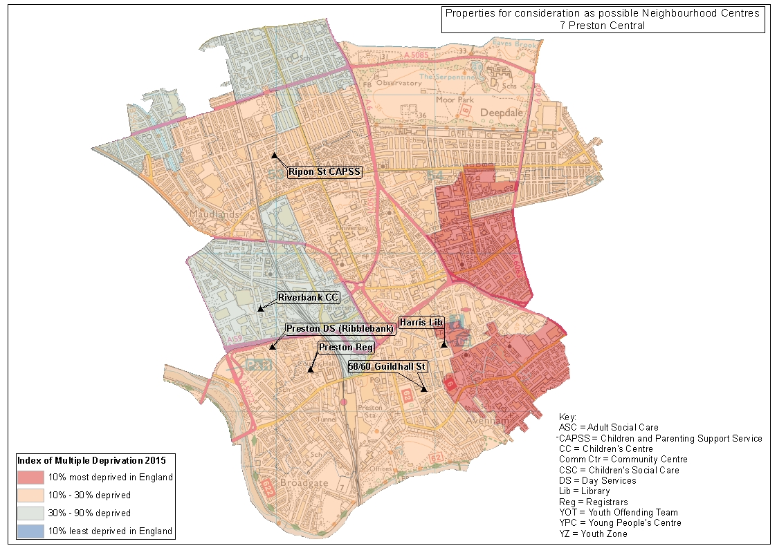
SPA8 Skelmersdale
Existing Service Delivery Premises | Calculated Service Delivery Premises | Proposed Reduction
10 | 6 | 4

SPA No. | SPA Name | Name | Current LCC functions
8 | Skelmersdale | West Lancs Youth Zone | Youth Zone | Youth Offending Team
8 | Skelmersdale | Skelmersdale First Steps Children's Centre | Children's Centre
8 | Skelmersdale | Skelmersdale Park Children's Centre | Children's Centre
8 | Skelmersdale | Fairlie CAPSS | CAPSS
8 | Skelmersdale | Skelmersdale Library | Library | Adult Social Care
8 | Skelmersdale | West Lancs Resource Centre (Daniels Lane) | Community Mental Health Team
8 | Skelmersdale | Upholland Children's Centre | Children's Centre
8 | Skelmersdale | West Lancs Day Services (Whiteledge) | Disability Day Service
8 | Skelmersdale | Digmoor Young People's Service | Young People's Centre
8 | Skelmersdale | Upholland Library | Library | Young People's Service

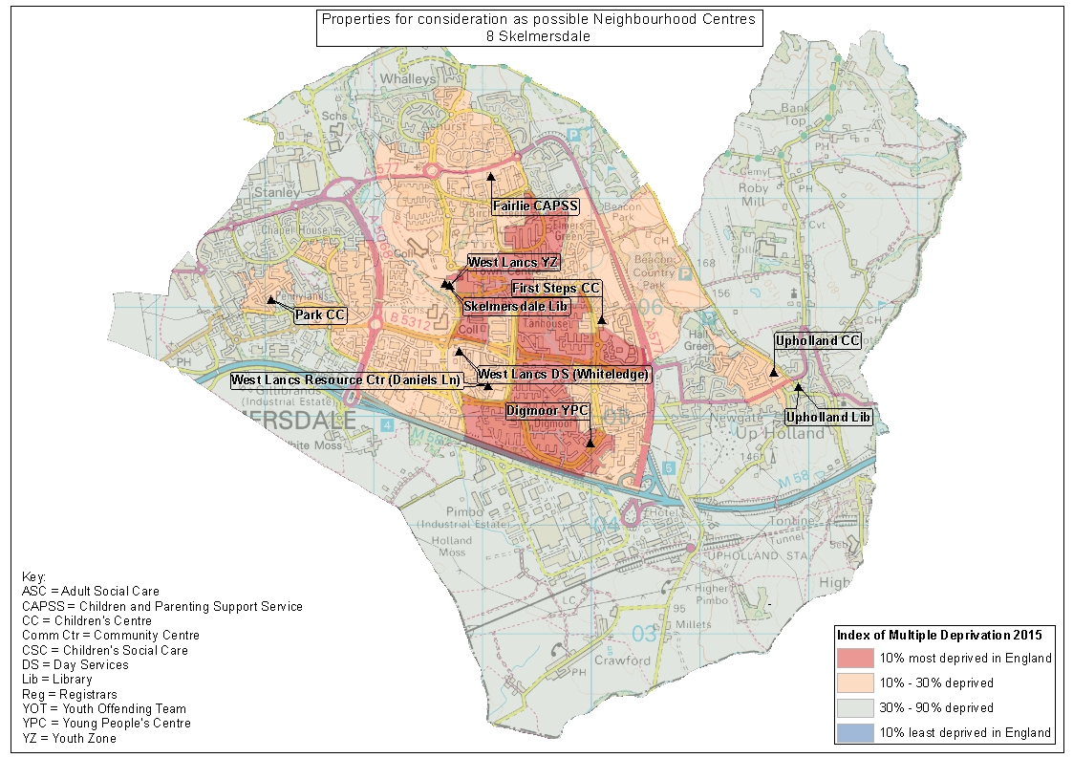
SPA9 Morecambe and Heysham
Existing Service Delivery Premises | Calculated Service Delivery Premises | Proposed Reduction
10 | 8 | 2

SPA No. | SPA Name | Name | Current LCC functions
9 | Morecambe and Heysham | Morecambe Poulton Children's Centre | Children's Centre
9 | Morecambe and Heysham | Morecambe Library | Library | Young People's Service |  | Welfare Rights
9 | Morecambe and Heysham | Morecambe Westgate Children's Centre | Children's Centre
9 | Morecambe and Heysham | Balmoral Children's Centre | Children's Centre
9 | Morecambe and Heysham | Lancaster CAPSS (Sefton Drive) | CAPSS
9 | Morecambe and Heysham | Heysham Children's Centre and YPC | Children's Centre |  | Young People's Service
9 | Morecambe and Heysham | Heysham Library | Library | Welfare Rights
9 | Morecambe and Heysham | Lancaster and Morecambe Day Services (Thorpe Avenue) | Disability Day Service
9 | Morecambe and Heysham | Ryelands Young People's Centre | Young People's Centre
9 | Morecambe and Heysham | Morecambe Registrars | Registrars

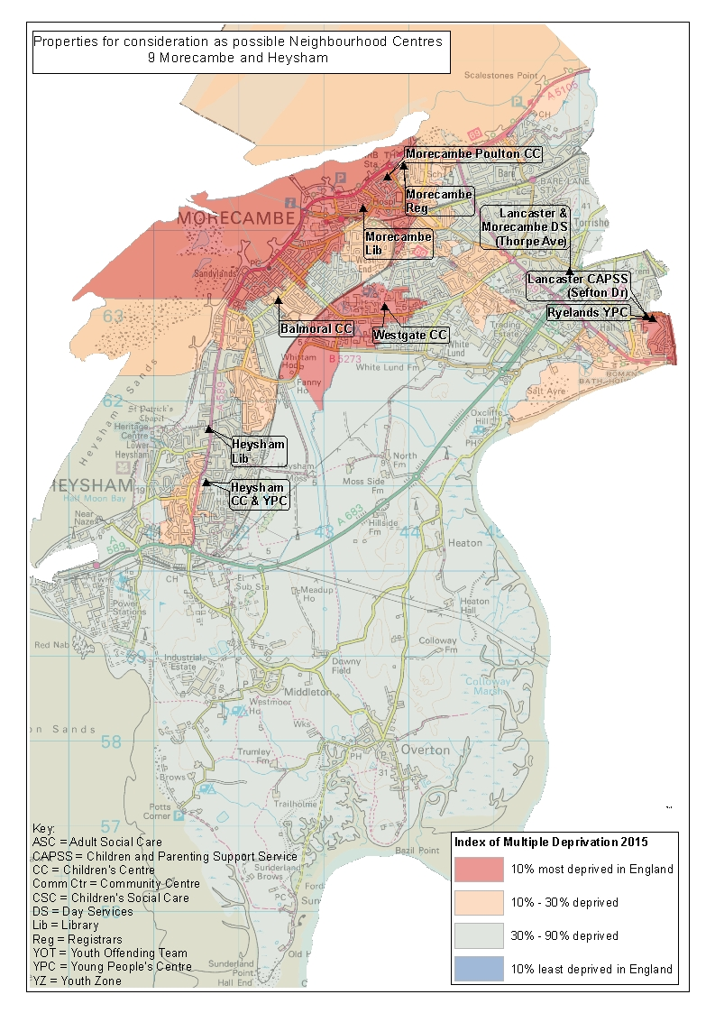
SPA10 Rawtenstall and Bacup
Existing Service Delivery Premises | Calculated Service Delivery Premises | Proposed Reduction
9 | 5 | 4

SPA No. | SPA Name | Name | Current LCC functions
10 | Rawtenstall and Bacup | The Maden Centre | Children's Centre | Young People's Service | Welfare Rights
10 | Rawtenstall and Bacup | Rawtenstall Library | Library
10 | Rawtenstall and Bacup | Bacup Library | Library
10 | Rawtenstall and Bacup | Rossendale Youth Zone | Youth Zone
10 | Rawtenstall and Bacup | Whitworth Library | Library
10 | Rawtenstall and Bacup | Whitworth Young People's Centre | Young People's Centre
10 | Rawtenstall and Bacup | Rossendale CAPSS | CAPSS Centre
10 | Rawtenstall and Bacup | Whitewell Bottom Community Centre | Community Association - no LCC service
10 | Rawtenstall and Bacup | Rawtenstall Registrars | Registrars

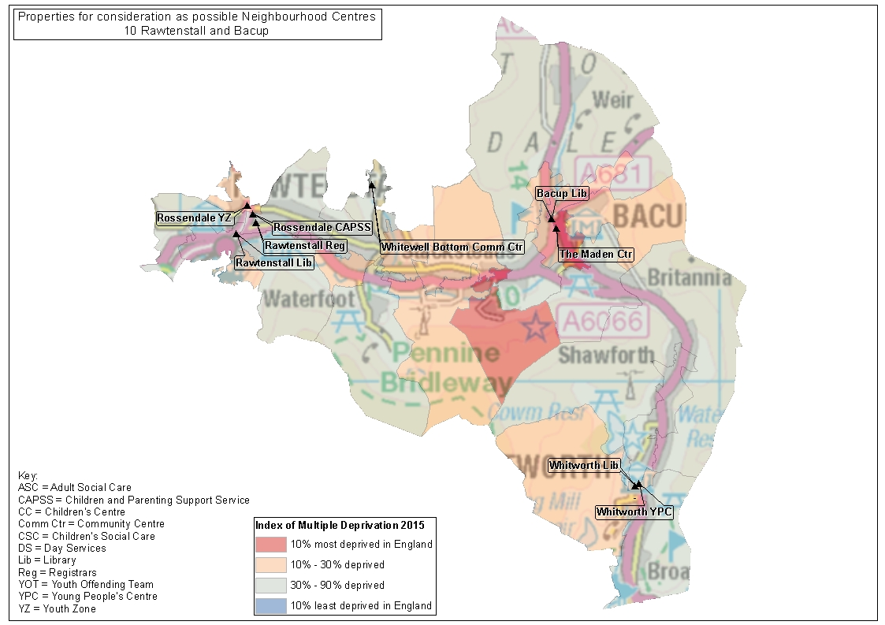
SPA11 Colne
Existing Service Delivery Premises | Calculated Service Delivery Premises | Proposed Reduction
9 | 3 | 6

SPA No. | SPA Name | Name | Current LCC functions
11 | Colne | Colne Children's Centre | Children's Centre
11 | Colne | Colne Library | Library | Welfare Rights
11 | Colne | Colne Young People's Centre | Young People's Centre
11 | Colne | Byron View Day Centre | Older People's Day Centre
11 | Colne | Pendle CAPSS | CAPSS
11 | Colne | Earby Community Centre | Young People's Centre
11 | Colne | Trawden Library | Library |  | Children's Centre
11 | Colne | Earby Library | Library
11 | Colne | Trawden Young People's Centre | Young People's Centre

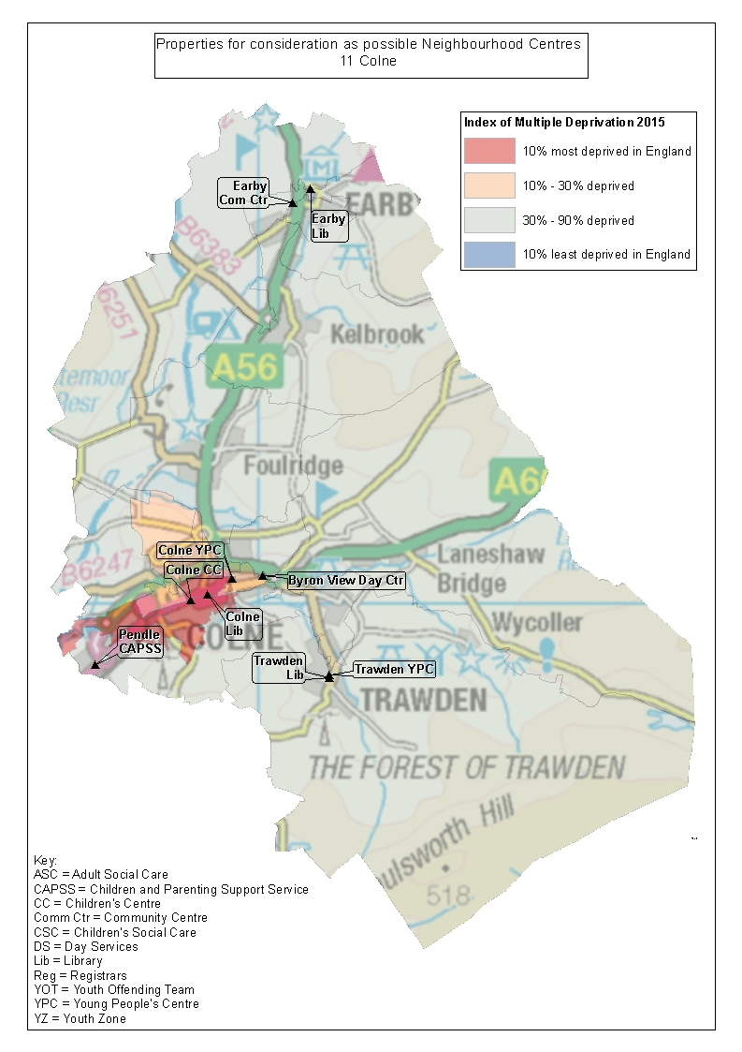
SPA12 Burnley Outer
Existing Service Delivery Premises | Calculated Service Delivery Premises | Proposed Reduction
5 | 3 | 2

SPA No. | SPA Name | Name | Current LCC functions
12 | Burnley Outer | Padiham Young People's Centre | Young People's Centre
12 | Burnley Outer | Rosegrove Library | Library
12 | Burnley Outer | Gannow Community Centre | Community Association - no LCC service
12 | Burnley Outer | Padiham Library | Library
12 | Burnley Outer | Hapton Young People's Centre | Young People's Centre

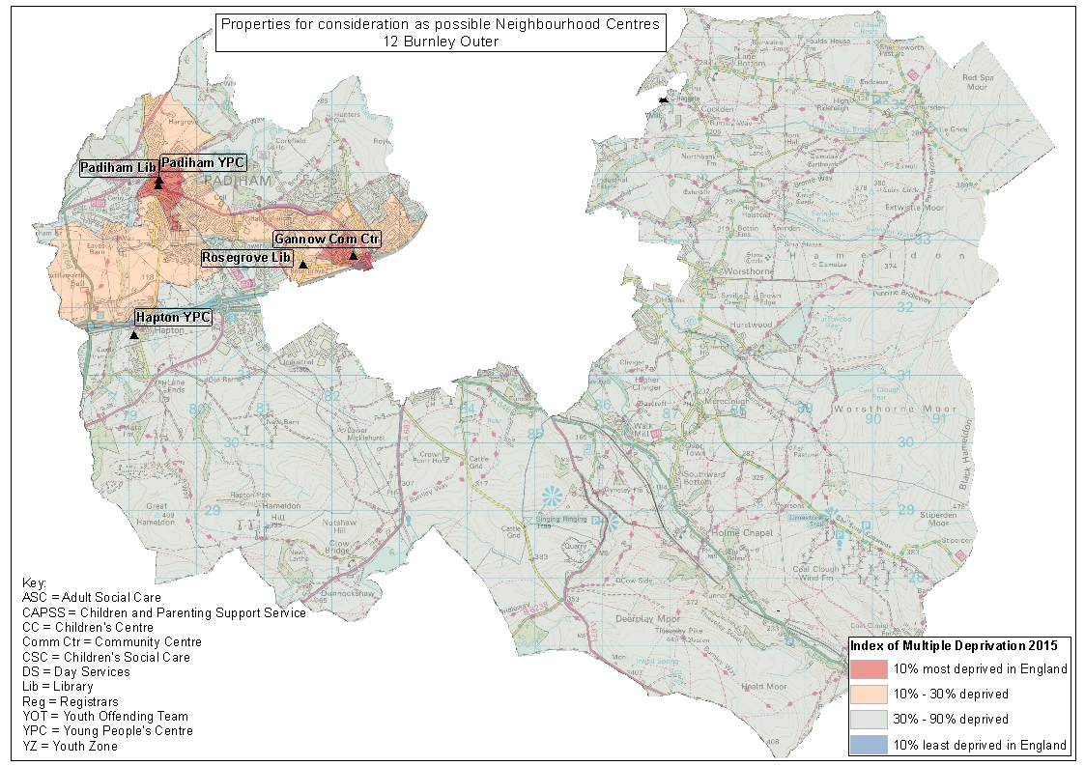
SPA13 Hyndburn West
Existing Service Delivery Premises | Calculated Service Delivery Premises | Proposed Reduction
4 | 2 | 2

SPA No. | SPA Name | Name | Current LCC functions
13 | Hyndburn West | Great Harwood Young People's Centre | Young People's Centre
13 | Hyndburn West | Rishton Library | Library
13 | Hyndburn West | Copper House Children's Centre | Children's Centre
13 | Hyndburn West | Great Harwood Library | Library

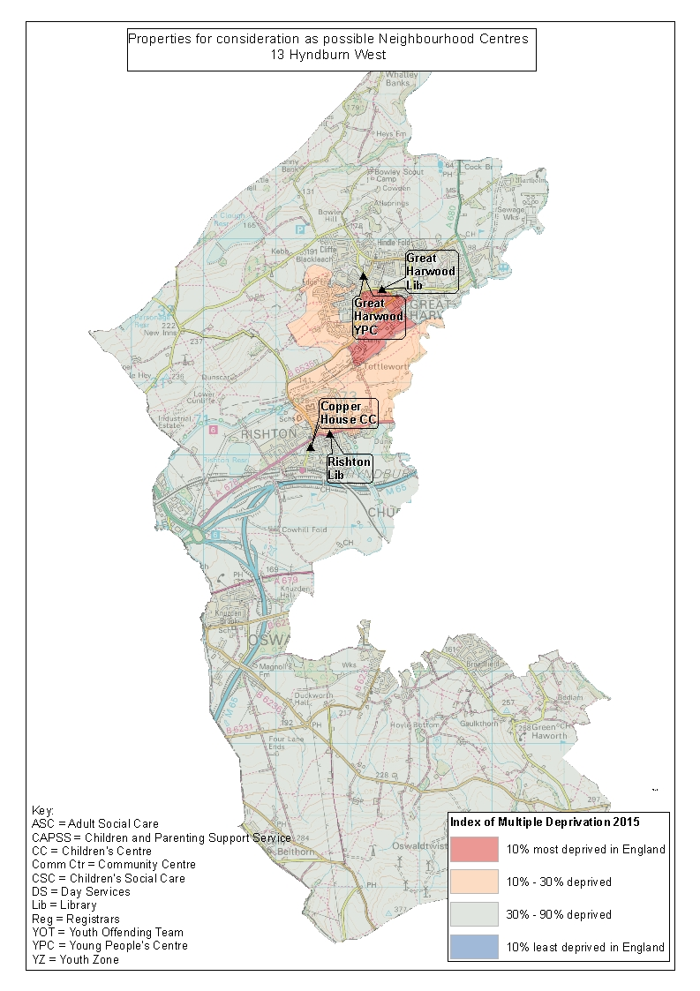
SPA14 Lancaster Central
Existing Service Delivery Premises | Calculated Service Delivery Premises | Proposed Reduction
6 | 4 | 2

SPA No. | SPA Name | Name | Current LCC functions
14 | Lancaster Central | Firbank Children's Centre | Children's Centre
14 | Lancaster Central | Lune Park Children's Centre | Children's Centre
14 | Lancaster Central | Vale View Day Centre | Older People's Day Centre
14 | Lancaster Central | Lancaster Central Library | Library
14 | Lancaster Central | Barton Road Young People's Centre | Young People's Centre
14 | Lancaster Central | Lancaster Registrars | Registrars

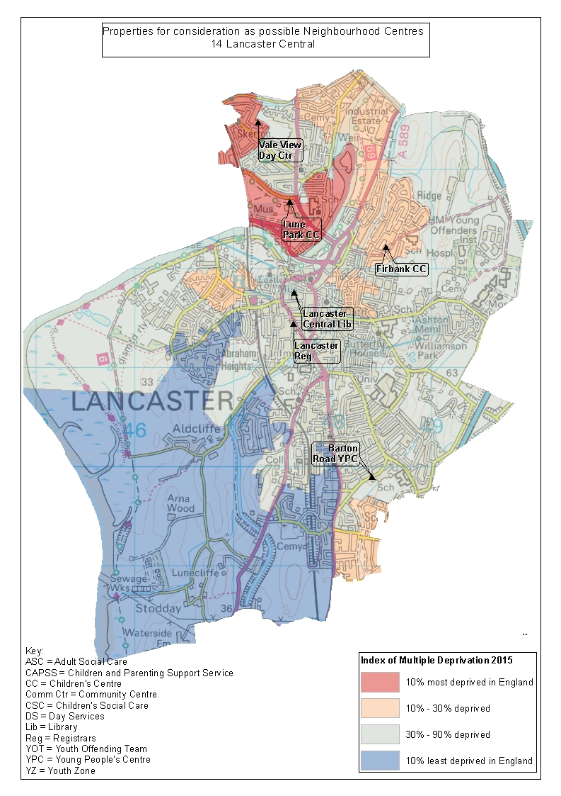
SPA15 Chorley Central
Existing Service Delivery Premises | Calculated Service Delivery Premises | Proposed Reduction
11 | 5 | 6

SPA No. | SPA Name | Name | Current LCC functions
15 | Chorley Central | Chorley Day Services (Bankside) | Disability Day Service
15 | Chorley Central | Chorley Library | Library | Welfare Rights | Young People's Service | Children Missing Education | Pupil Attendance Team
15 | Chorley Central | Chorley Youth Offending Team | Youth Offending Team
15 | Chorley Central | The Hawthorns CAPSS | CAPSS Centre
15 | Chorley Central | Chorley Registrars | Registrars
15 | Chorley Central | Fosterfield Day Centre | Older People's Day Centre
15 | Chorley Central | Chorley District Day Service (Holly Tree) | Disability Day Service
15 | Chorley Central | Chorley Youth Zone | Youth Zone
15 | Chorley Central | Woodlands Centre | Conferencing
15 | Chorley Central | Coppull Library | Library
15 | Chorley Central | Coppull Young People's Centre | Young People's Centre

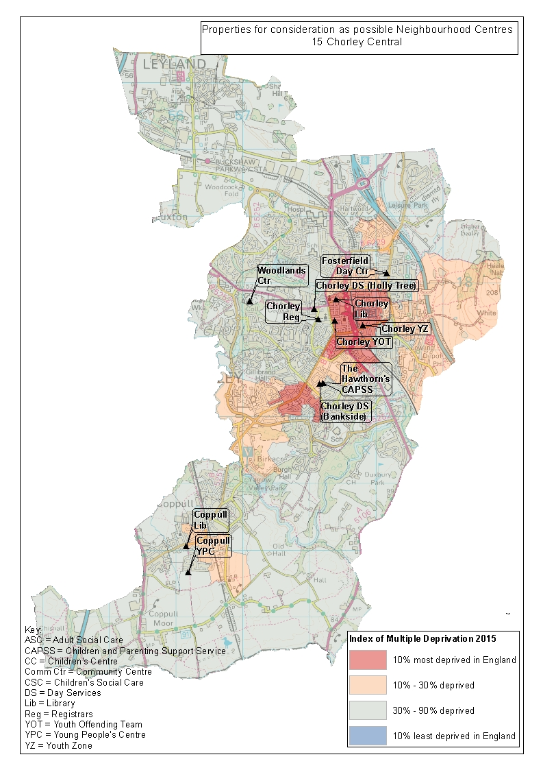
SPA16 Preston West
Existing Service Delivery Premises | Calculated Service Delivery Premises | Proposed Reduction
7 | 3 | 4

SPA No. | SPA Name | Name | Current LCC functions
16 | Preston West | Lady Elsie Finney Day Centre | Older People's Day Centre
16 | Preston West | Ingol Library | Library
16 | Preston West | Scientific Services Lab | Scientific Services Lab
16 | Preston West | Preston West Children's Centre | Children's Centre
16 | Preston West | Ashton YPC (Star) | Young People's Centre
16 | Preston West | Savick Library | Library | Welfare Rights
16 | Preston West | Lancashire Certificate Service (Quayside Court) | Registrars

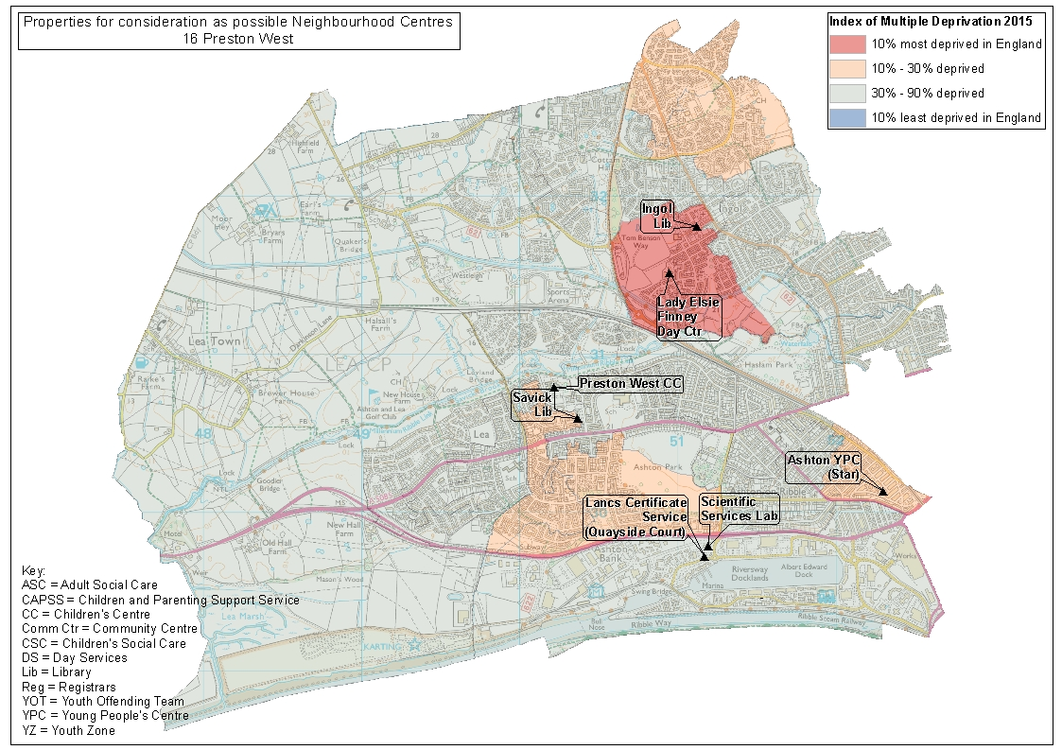
SPA17 Leyland
Existing Service Delivery Premises | Calculated Service Delivery Premises | Proposed Reduction
7 | 3 | 4

SPA No. | SPA Name | Name | Current LCC functions
17 | Leyland | Wade Hall Children's Centre | Children's Centre
17 | Leyland | Leyland Learning Centre | Conferencing
17 | Leyland | King Street Day Centre | Older People's Day Centre
17 | Leyland | South Ribble Youth Zone | Youth Zone
17 | Leyland | South Ribble Day Services (Crossways) | Disability Day Service
17 | Leyland | Leyland Library | Library
17 | Leyland | Wellfield Children's Centre | Children's Centre

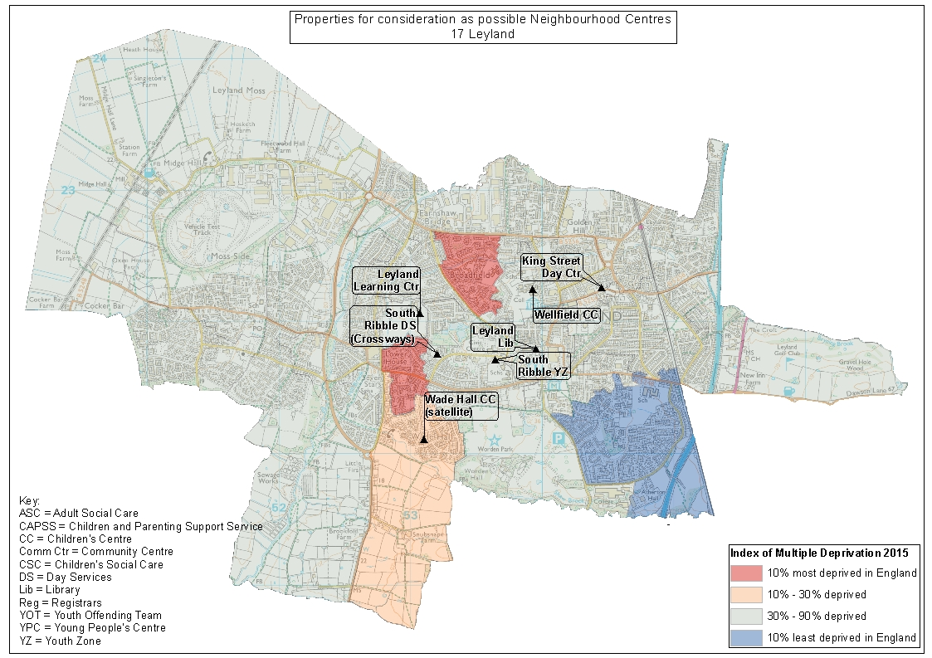
SPA18 Barnoldswick
Existing Service Delivery Premises | Calculated Service Delivery Premises | Proposed Reduction
2 | 1 | 1

SPA No. | SPA Name | Name | Current LCC functions
18 | Barnoldswick | Barnoldswick Library | Library
18 | Barnoldswick | Barnoldswick Young People's Centre | Young People's Centre

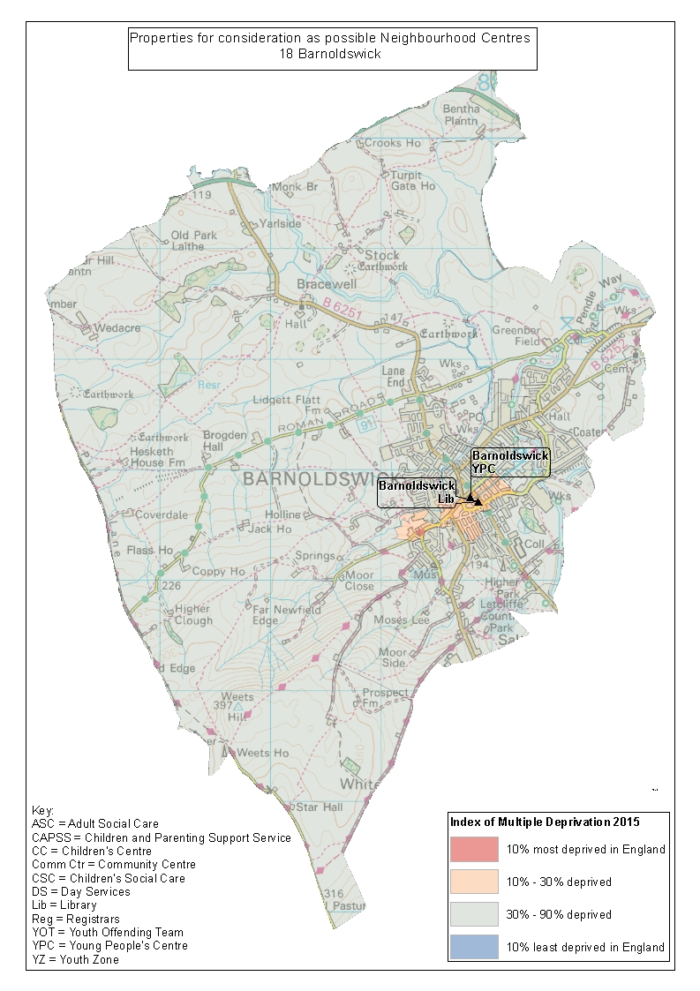
SPA19 Rossendale West
Existing Service Delivery Premises | Calculated Service Delivery Premises | Proposed Reduction
2 | 2 | 0

SPA No. | SPA Name | Name | Current LCC functions
19 | Rossendale West | Haslingden Library | Library | Young People's Service | Welfare Rights
19 | Rossendale West | Crawshawbooth Library | Library

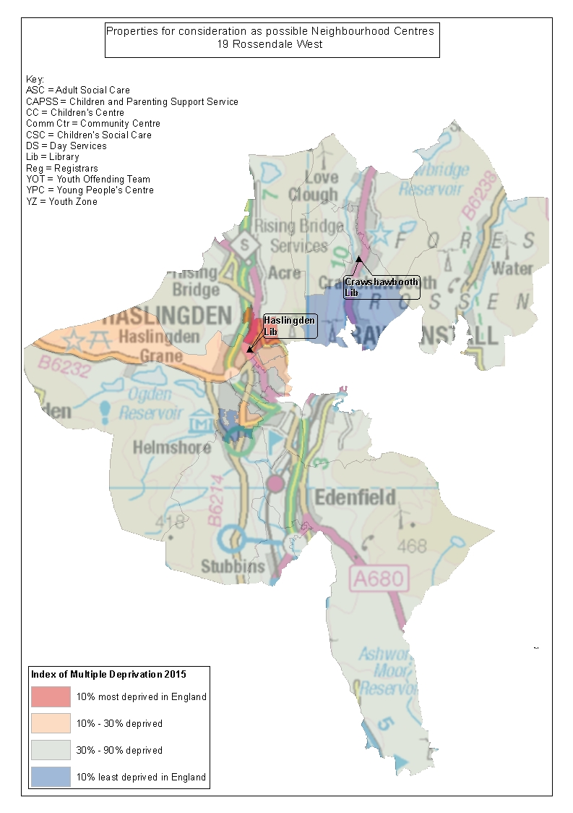
SPA20 South Ribble East
Existing Service Delivery Premises | Calculated Service Delivery Premises | Proposed Reduction
7 | 4 | 3

SPA No. | SPA Name | Name | Current LCC functions
20 | South Ribble East | Lostock Hall Library | Library | Children's Centre
20 | South Ribble East | Bamber Bridge Library | Library
20 | South Ribble East | Walton-le-Dale Young People's Centre | Young People's Centre
20 | South Ribble East | Penwortham Kingsfold Library | Library
20 | South Ribble East | Kingsfold Children's Centre | Children's Centre
20 | South Ribble East | Bamber Bridge Children's Centre | Children's Centre
20 | South Ribble East | Bamber Bridge Day Centre (Bridge Suite) | Disability Day Service

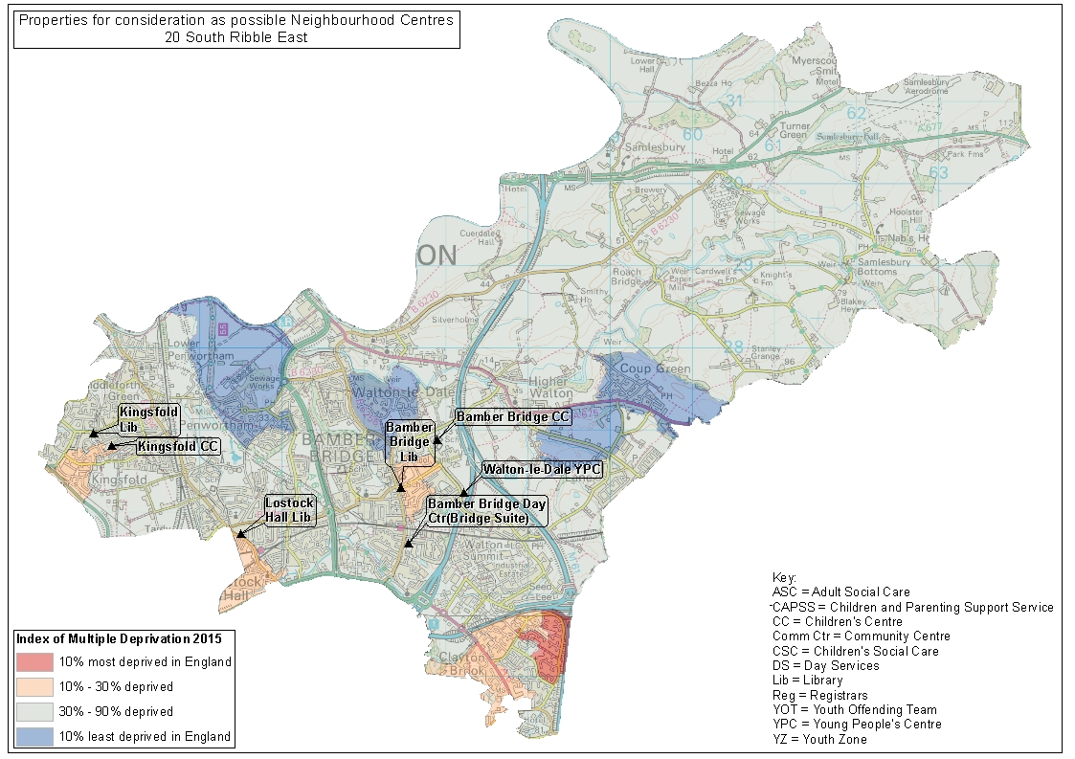
SPA21 Lytham St Annes
Existing Service Delivery Premises | Calculated Service Delivery Premises | Proposed Reduction
6 | 3 | 3

SPA No. | SPA Name | Name | Current LCC functions
21 | Lytham St Annes | Fylde CAPSS and Oak Tree Children's Centre (Sydney St) | CAPSS Centre | Children's Centre | Welfare Rights
21 | Lytham St Annes | The Woodlands Resource Centre | Community Mental Health Team
21 | Lytham St Annes | St Anne's Library | Library
21 | Lytham St Annes | Lytham Library (Clifton Street) | Library | Registrars
21 | Lytham St Annes | Lytham Children's Centre (YMCA) | Children's Centre
21 | Lytham St Annes | Lytham Ansdell Library | Library

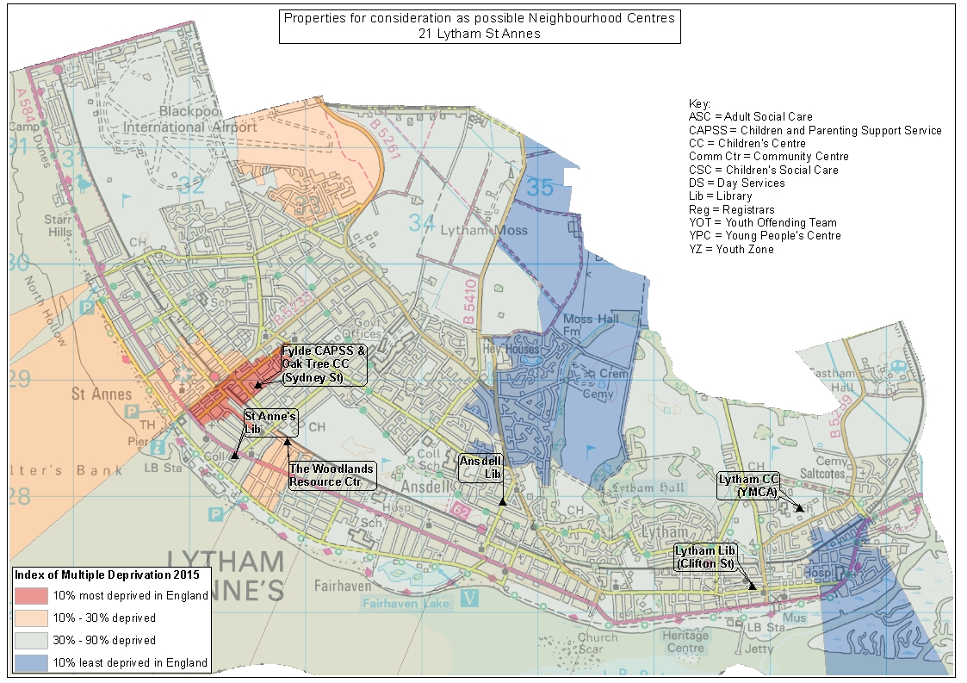
SPA22 Thornton Cleveleys
Existing Service Delivery Premises | Calculated Service Delivery Premises | Proposed Reduction
9 | 3 | 6

SPA No. | SPA Name | Name | Current LCC functions
22 | Thornton Cleveleys | Cleveleys Library | Library | Children's Centre
22 | Thornton Cleveleys | Thornton Cleveleys Children's Centre | Children's Centre
22 | Thornton Cleveleys | Poulton Library | Library | Welfare Rights
22 | Thornton Cleveleys | Thornton Library | Library
22 | Thornton Cleveleys | Thornton Cleveleys Adult Social Care | Adult Social Care
22 | Thornton Cleveleys | Teal Close Day Centre | Older People's Day Centre
22 | Thornton Cleveleys | Thornton Young People's Centre | Young People's Centre
22 | Thornton Cleveleys | Thornton Youth Offending Team | Youth Offending Team
22 | Thornton Cleveleys | Poulton-Le-Fylde Children's Centre | Children's Centre

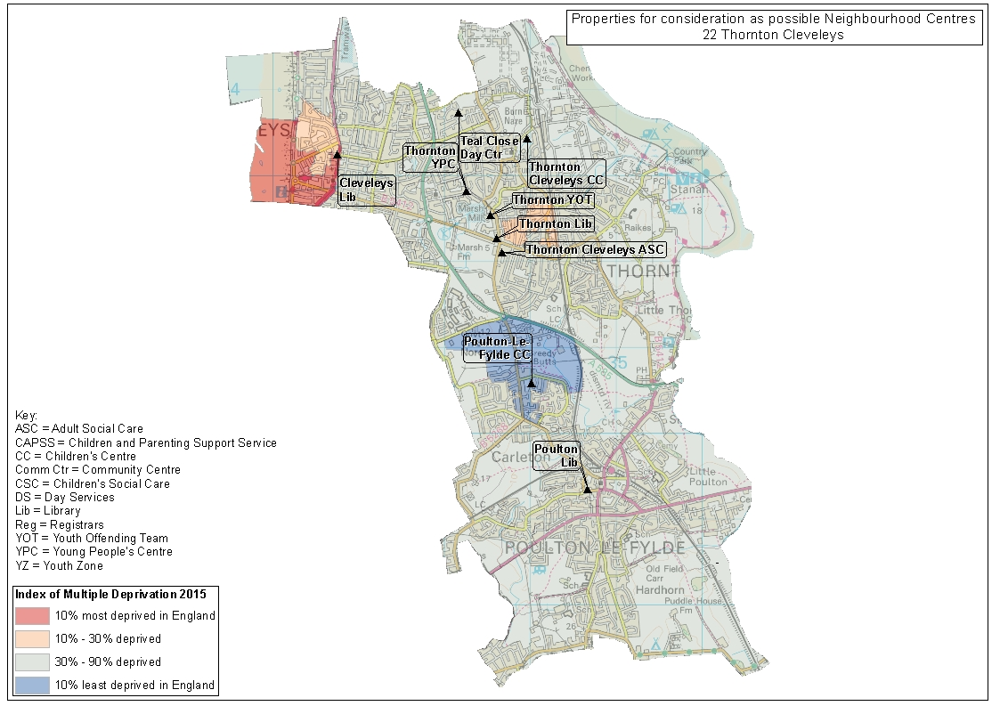
SPA23 West Lancashire West
Existing Service Delivery Premises | Calculated Service Delivery Premises | Proposed Reduction
5 | 2 | 3

SPA No. | SPA Name | Name | Current LCC functions
23 | W Lancashire West | The Grove YPC and Children's Centre | Young People's Centre | Children's Centre | Welfare Rights
23 | W Lancashire West | Tarleton Library | Library
23 | W Lancashire West | Burscough Bridge Bus/Rail Interchange | Transport
23 | W Lancashire West | Hesketh Children's Centre | Children's Centre
23 | W Lancashire West | Burscough Library | Library

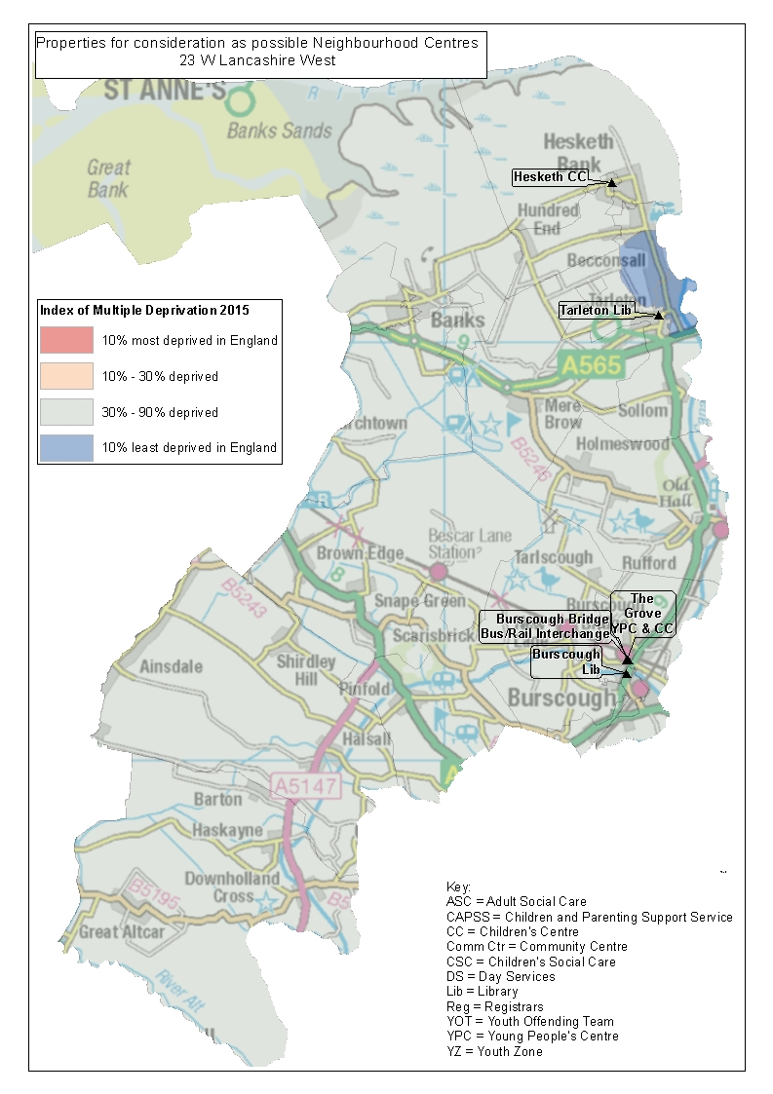
SPA24 Wyre Rural
Existing Service Delivery Premises | Calculated Service Delivery Premises | Proposed Reduction
6 | 2 | 4

SPA No. | SPA Name | Name | Current LCC functions
24 | Wyre Rural | Knott End Library | Library
24 | Wyre Rural | Garstang Library | Library
24 | Wyre Rural | Garstang Young People's Centre | Young People's Centre
24 | Wyre Rural | Preesall Young People's Centre | Young People's Centre
24 | Wyre Rural | Preesall Children's Centre | Children's Centre
24 | Wyre Rural | Over Wyre Children's Centre | Children's Centre

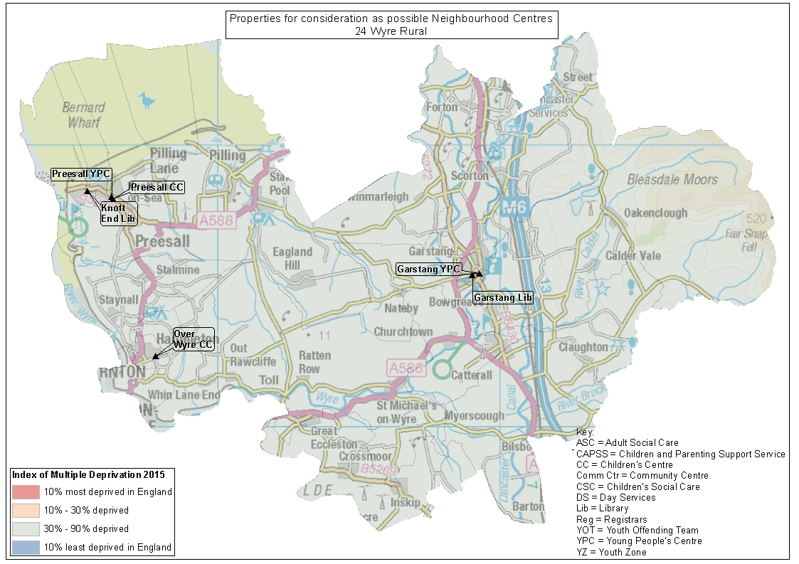
SPA25 Lancaster Coast
Existing Service Delivery Premises | Calculated Service Delivery Premises | Proposed Reduction
4 | 1 | 3

SPA No. | SPA Name | Name | Current LCC functions
25 | Lancaster Coast | The Carnforth Hub Children's Centre and YPC | Children's Centre | Young People's Service
25 | Lancaster Coast | Bolton-Le-Sands Library | Library
25 | Lancaster Coast | Carnforth Library | Library
25 | Lancaster Coast | Silverdale Library | Library

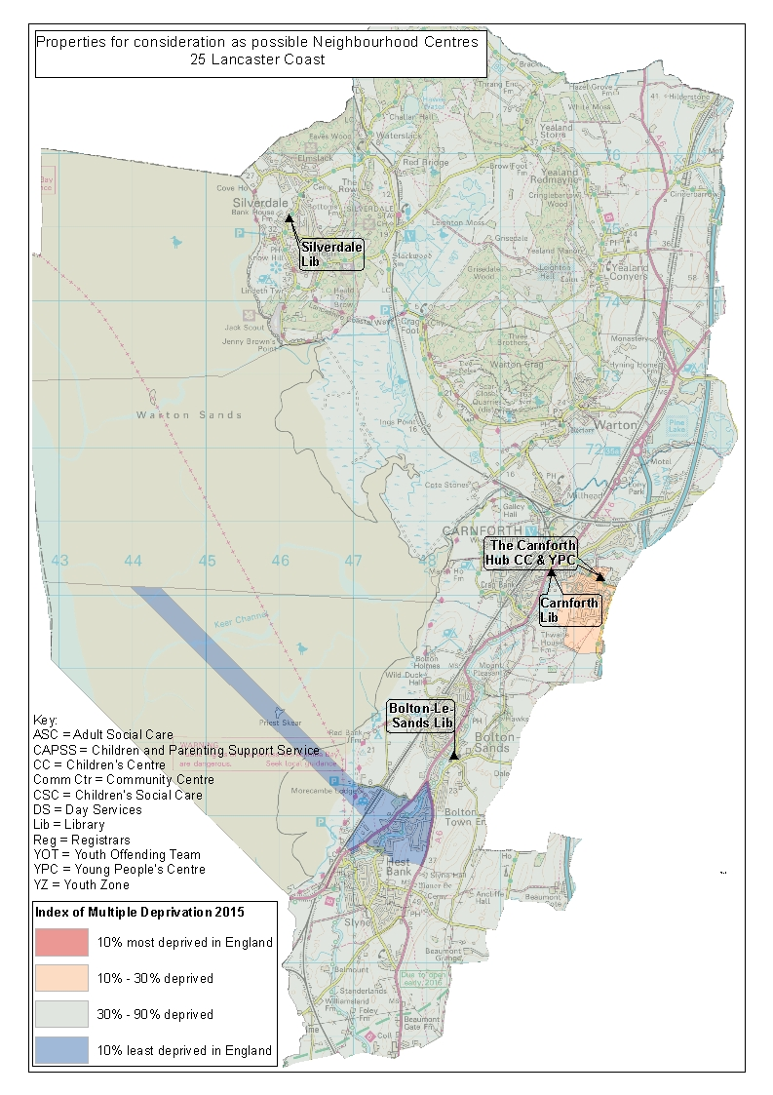
SPA26 Lancaster Rural
Existing Service Delivery Premises | Calculated Service Delivery Premises | Proposed Reduction
2 | 1 | 1

SPA No. | SPA Name | Name | Current LCC functions
26 | Lancaster Rural | Halton Library | Library | Children's Centre
26 | Lancaster Rural | Galgate Children's Centre | Children's Centre

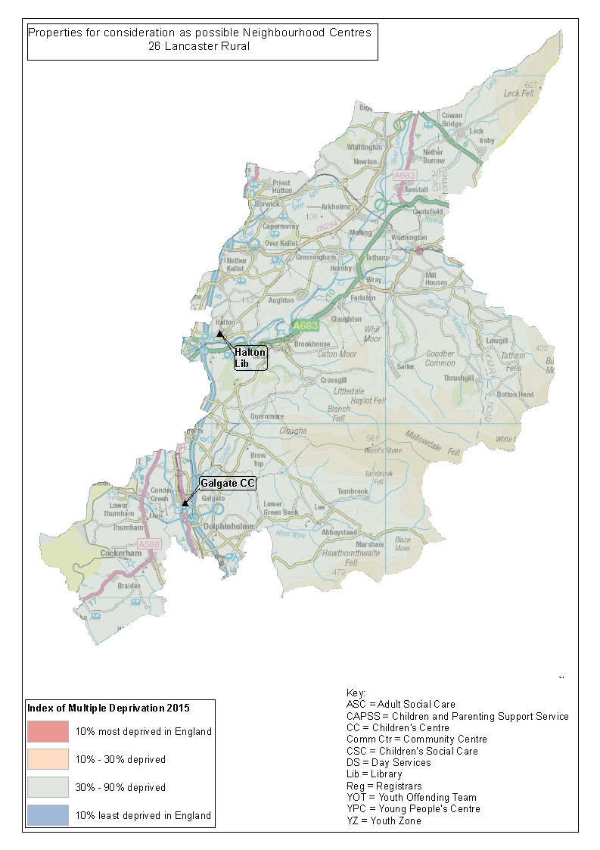
SPA27 Fylde East and Broughton
Existing Service Delivery Premises | Calculated Service Delivery Premises | Proposed Reduction
9 | 2 | 7

SPA No. | SPA Name | Name | Current LCC functions
27 | Fylde East and Broughton | Fylde Day Services (Sunnybank) | Disability Day Service
27 | Fylde East and Broughton | Milbanke Day Centre | Older People's Day Centre
27 | Fylde East and Broughton | Kirkham Library | Library
27 | Fylde East and Broughton | Fylde Youth Zone | Youth Zone
27 | Fylde East and Broughton | Kirkham Young People's Centre | Young People's Centre
27 | Fylde East and Broughton | Freckleton Library | Library
27 | Fylde East and Broughton | Weeton Camp Children's Centre | Children's Centre
27 | Fylde East and Broughton | Lower Lane Young People's Centre | Young People's Centre | Early Years' Service
27 | Fylde East and Broughton | Barton St Lawrence Children's Centre | Children's Centre

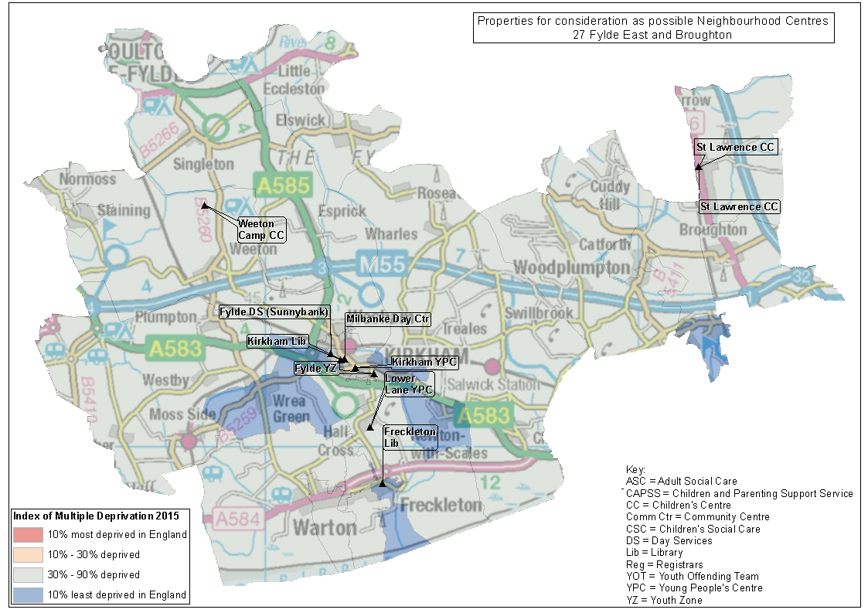
SPA28 Pendle Hill
Existing Service Delivery Premises | Calculated Service Delivery Premises | Proposed Reduction
10 | 2 | 8

SPA No. | SPA Name | Name | Current LCC functions
28 | Pendle Hill | Whalley Library and Spring Wood Children's Centre | Library | Children's Centre
28 | Pendle Hill | Ribble Valley Day Services (Pendleton Brook) | Disability Day Service
28 | Pendle Hill | Barrowford Library | Library
28 | Pendle Hill | Ribble Valley Youth Zone | Youth Zone
28 | Pendle Hill | Clitheroe Library | Library
28 | Pendle Hill | Mearley Fold Day Centre | Older People's Day Centre
28 | Pendle Hill | Wheatley Lane Library | Library
28 | Pendle Hill | Barrowford Children's Centre | Children's Centre
28 | Pendle Hill | Chatburn Library | Library
28 | Pendle Hill | Read Library | Library
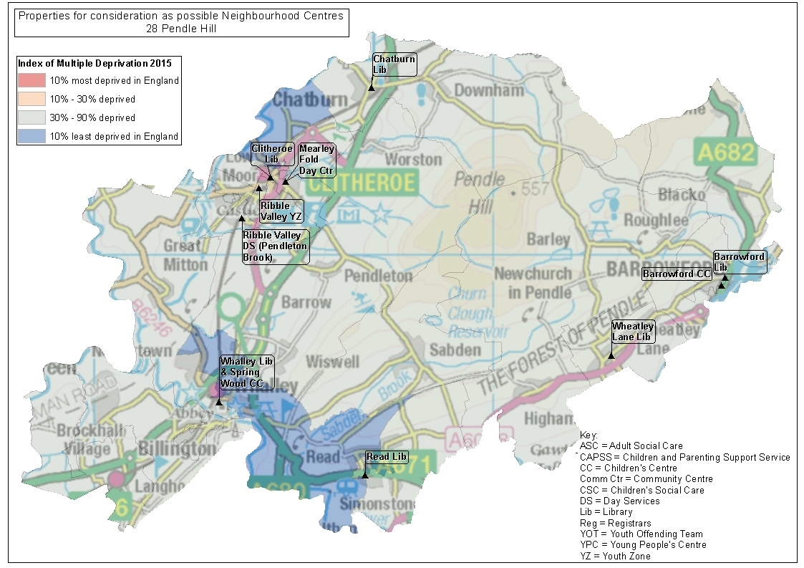
SPA29 Chorley East
Existing Service Delivery Premises | Calculated Service Delivery Premises | Proposed Reduction
3 | 1 | 2

SPA No. | SPA Name | Name | Current LCC functions
29 | Chorley East | Clayton Green Library | Library
29 | Chorley East | Adlington Library | Library | Children's Centre
29 | Chorley East | Brinscall Millfields Children's Centre | Children's Centre

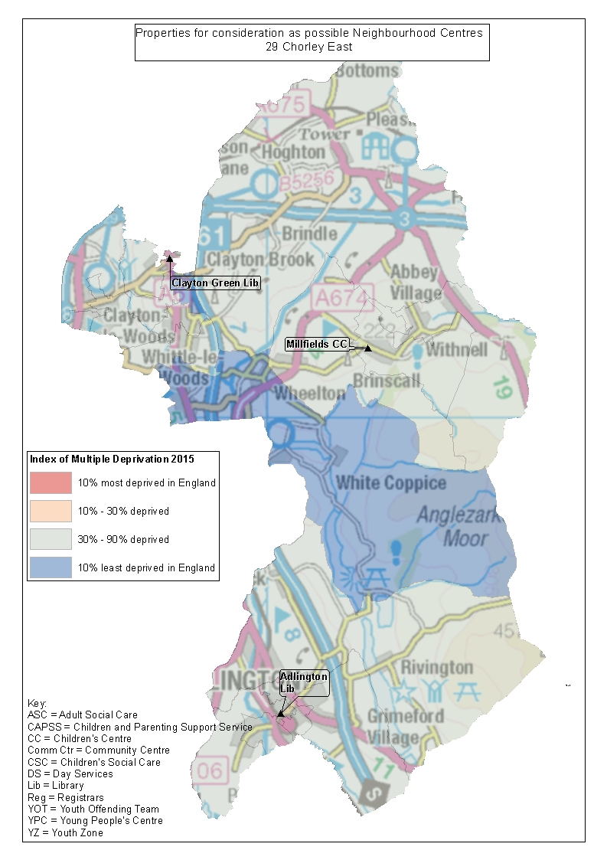
SPA30 Ormskirk and Newburgh
Existing Service Delivery Premises | Calculated Service Delivery Premises | Proposed Reduction
5 | 1 | 4

SPA No. | SPA Name | Name | Current LCC functions
30 | Ormskirk and Newburgh | Ormskirk Library | Library
30 | Ormskirk and Newburgh | West Lancashire Registrars | Registrars
30 | Ormskirk and Newburgh | Ormskirk Derby Street Day Centre (older people) | Older People's Day Centre
30 | Ormskirk and Newburgh | Ormskirk 5A Derby Street Day Centre (disability) | Disability Day Service
30 | Ormskirk and Newburgh | Ormskirk Mere Brook Day Centre | Older People's Day Centre

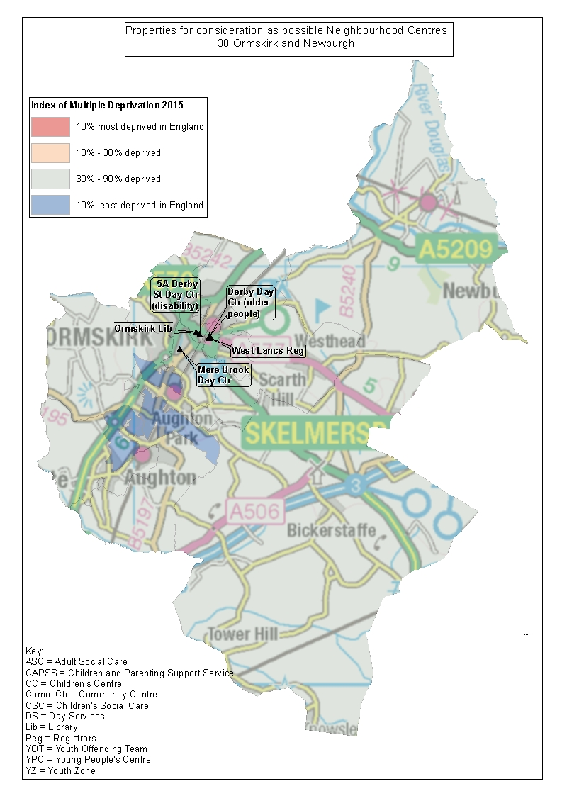
SPA31 Preston North
Existing Service Delivery Premises | Calculated Service Delivery Premises | Proposed Reduction
2 | 1 | 1

SPA No. | SPA Name | Name | Current LCC functions
31 | Preston North | Sharoe Green Library | Library | Children's Centre
31 | Preston North | Fulwood Library (Garstang Road) | Library

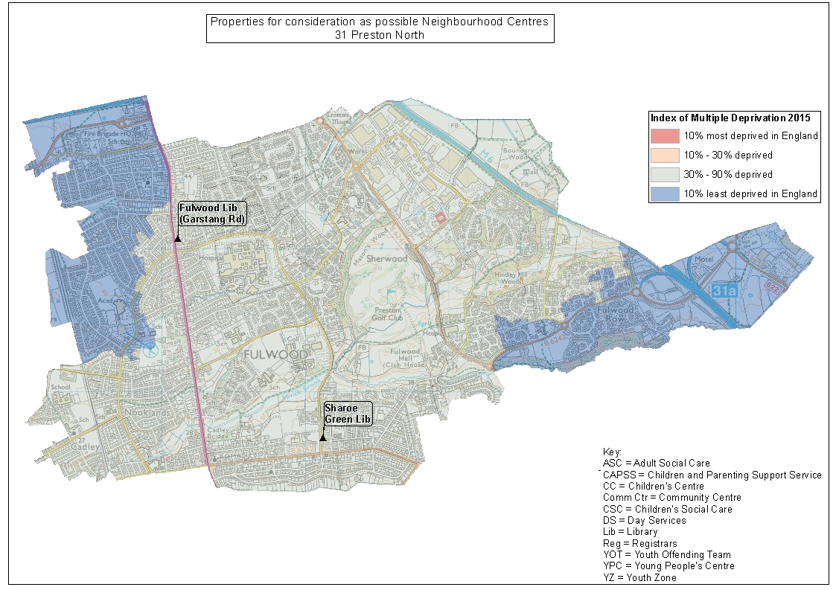
SPA32 Bowland
Existing Service Delivery Premises | Calculated Service Delivery Premises | Proposed Reduction
6 | 1 | 5

SPA No. | SPA Name | Name | Current LCC functions
32 | Bowland | Longridge Library | Library
32 | Bowland | Longridge Young People's Centre | Young People's Centre
32 | Bowland | Willows Park Children's Centre | Children's Centre
32 | Bowland | Slaidburn Young People's Centre | Young People's Centre
32 | Bowland | Mellor Library | Library
32 | Bowland | Alston Hall | Conferencing

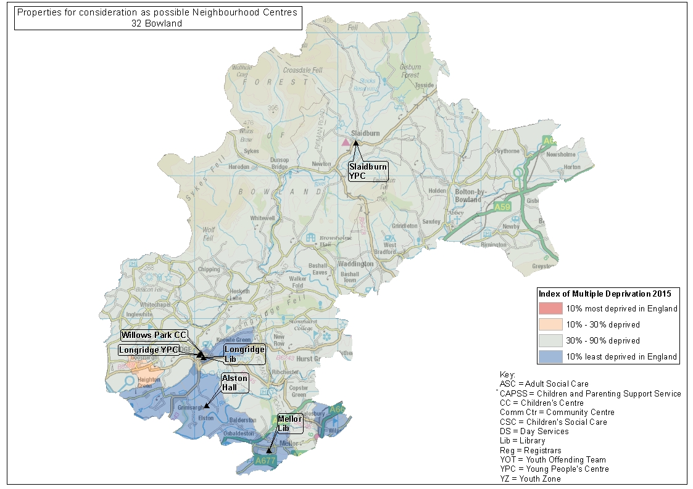
SPA33 Chorley West
Existing Service Delivery Premises | Calculated Service Delivery Premises | Proposed Reduction
5 | 1 | 4

SPA No. | SPA Name | Name | Current LCC functions
33 | Chorley West | Euxton Library | Library
33 | Chorley West | Parbold Library | Library
33 | Chorley West | Eccleston Library | Library
33 | Chorley West | Eccleston Young People's Centre | Young People's Centre
33 | Chorley West | Blossomfield Children's Centre | Children's Centre

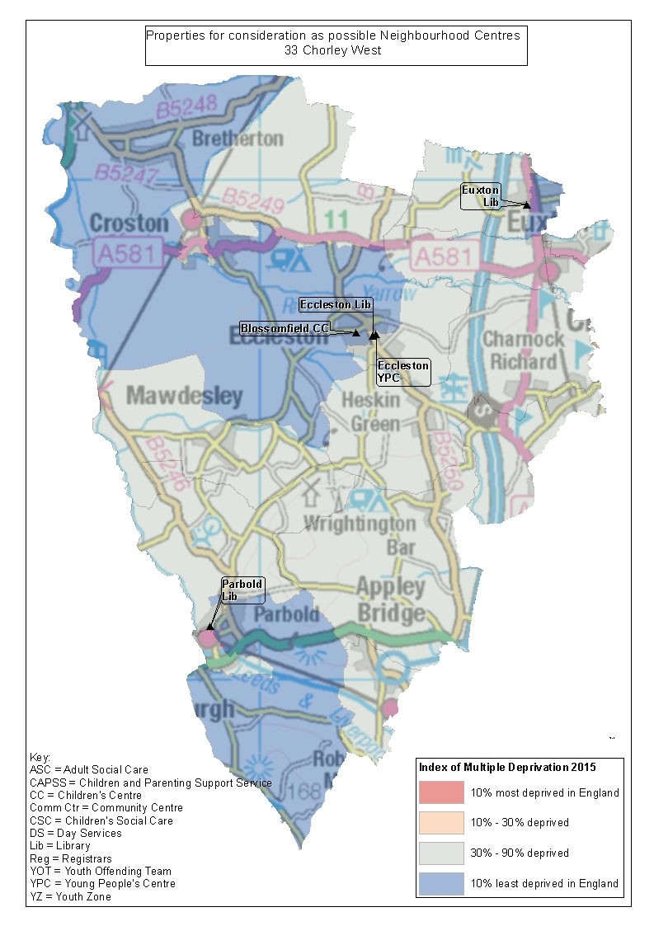
SPA34 South Ribble West
Existing Service Delivery Premises | Calculated Service Delivery Premises | Proposed Reduction
4 | 1 | 3

SPA No. | SPA Name | Name | Current LCC functions
34 | South Ribble West | Longton Children's Centre | Children's Centre
34 | South Ribble West | Longton Library | Library
34 | South Ribble West | Penwortham Young People's Centre | Young People's Centre
34 | South Ribble West | Penwortham Library (Liverpool Road) | Library

